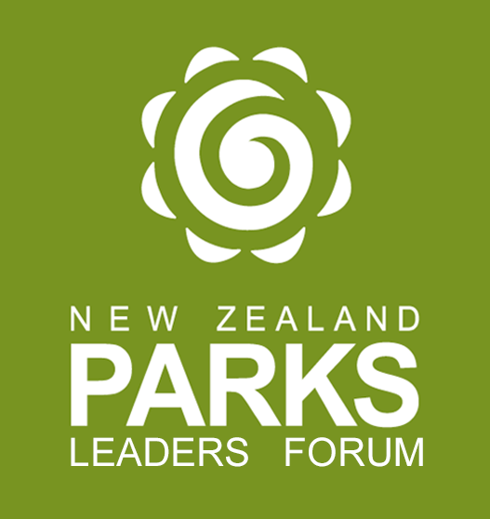
Parks Leaders Forum
2024 Papatūānuku Outstanding Parks Leader Award
Nomination Information and Forms for Applicants

The New Zealand Parks Leaders Forum recognises excellence, innovation, and effectiveness within the parks sector. We celebrate the achievement and service of individuals whose commitment and contribution promotes best practice within the parks industry.

DEADLINE FOR NOMINATIONS: 28TH March 2024, 4:00pm
BY E-MAIL ONLY
PLF Office, C/- convenor@plf.org.nz

This nomination pack is for the Outstanding Parks Leader Award - Papatūānuku

Pack includes:

Judging criteria for the Awards
Award Nomination Form

Appendices:
Lodging your nomination

The Outstanding Parks Leader Award

Parks Leaders Forum individual awards recognise significant achievement and service to the Parks industry and contributions to the ongoing development of the industry. The awards are recognition for sustained industry leadership that makes a significant difference to the art, science, and practice of the parks industry.

Awards are not intended as recognition for a single event or activity and will be awarded to recipients who have demonstrated leadership and practice that has contributed to the development of parks practice nationally (and/ or internationally) over a significant period of time. The decision of the judging panel will be final and no appeals will be permitted.

The identity of nominees will be confidential to the judging panel and only the winner will be announced.

Judging Criteria for the Outstanding Parks Leader Award:

The following criteria will be used for judging. The nomination MUST respond to each of the judging criteria under the criteria heading (e.g., 1-8). Failure to address all criteria may result in nominations being disqualified.

- Contribution to the sector within the nominee’s paid employment
- Contribution to the sector in a voluntary or non-paid capacity
- Length of service to the sector
- Relevant qualifications, awards and recognition gained by nominee
- Degree of innovation or uniqueness of any contribution made
- The impact of the work of the nominee
- The output of their opinion and the leadership role they have taken such as research, discussion papers and contributions to industry training
- Letters of support from at least two industry peers of good standing.

Preparing your Nomination

- The nomination should be no longer than four single sided A4 pages (excluding the cover form below).
- The nomination MUST respond to each of the judging criteria under the criteria heading.
- The nomination may include a photograph of the nominee.
- The nomination must include the signature of agreement of the person nominated and full name of the individual or regional committee nominating the individual for the award.

Nomination for:
OUTSTANDING PARKS LEADER AWARD 2024

Contact information for person being nominated
Name of Nominee:
Organisation:
Address:
Telephone:
Email:
Contact information for person nominating
Name of Nominator:
Organisation:
Address:
Telephone:
Email:
Signature of Person nominating** Date / /2024

Signature of Person being nominated** Date / /2024

**Winners of individual awards will be promoted via the Parks Leaders Forum website, press releases, and will be announced in sector briefings and other places, as appropriate.**

Attach your nomination addressing all of the judging criteria
(Note: this nomination should be no longer than four pages- excluding this cover form, minimum font size 10 pt. Arial)

Send one PDF electronic copy of your nomination to: convenor@plf.org.nz by 28THMarch 2024, 4:00pm

